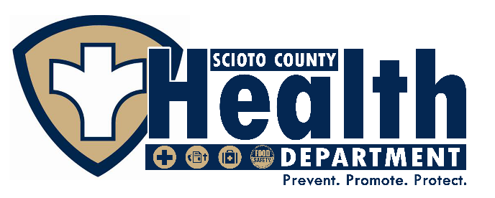
SCIOTO COUNTY HEALTH DEPARTMENT

PERFORMANCE MANAGEMENT AND QUALITY IMPROVEMENT PLAN
2019-2024

Approved & Adopted: 7/8/2022

Table of Contents
Executive Summary 3
Linkages to Other Plans…………………………………………………………………………...3
Glossary of QI Terms & Acronyms 6
Roles and Responsibilities 7
History of Performance Management and Quality Improvement 10
Performance Management and Quality Improvement Plan Development 10
Scioto County Health Department Performance Management Plan, Purpose and Goals 16
Organizational Structure to Support Performance Management and Quality Improvement 16
Identification of PM Coordinator 17
Identification Performance Standards of Core Programs 17
Setting Performance Standards and Objectives for each Core Program 18
Data Collection, Monitoring, Measure and Tracking…………………………………………18
Reporting and Sharing Performance Objectives 19
Identification of Success/Improvement Strategies for Performance Objectives………………19
Completing Agency Performance Management Self-Assessment…………………………….19
Review and Revision of the Written Plan 19
SCHD Quality Improvement Plan 20
Quality Improvement Purpose………………………………………………………….………..21
Culture of Quality and Desire Future State……………………………………………………....22
Quality Improvement Structure…………………………………………………………………..22
Alignment of QI Plan with Other Department Plans……………………………………………..23
Linkage to the SHIP…………………………………………………………………………...23
Linkage to the CHIP…………………………………………………………………………..23
Scioto County Health Department QI Goals and Objectives…………………………………….25
Organizational Structure to Support Continuous Quality Improvement…………………………26
Quality Improvement Committee……………………………………………………………..26
Quality Improvement Team…………………………………………………………………...27
Reporting Out on QI Projects…………………………………………………………………….28
QI Training & Education…………………………………………………………………………28
Training for New Employees…………………………………………………………………28
Training for Existing Employees……………………………………………………………..28
QI Projects- Project Identification and Implementation………………………………………….28
Plan-Do-Check-Act Cycle (PDCA)………………………………………………………….29
QI Plan Management and Maintenance………………………………………………….………31
QI Improvement Project Monitoring…………………………………………………………….31
References 33
Appendices 34
Appendix A: QI Training Schedule 35
Appendix B: Project Submission Form 36
Appendix C: Project Charter Form 37
Appendix D: Quality Improvement Reporting Form 38
Appendix E: Storyboard Template 39
Appendix F: QI Project List 42

EXECUTIVE SUMMARY
The Quality Improvement (QI) Plan was created to enable Scioto County Health Department (SCHD) staff to more effectively achieve the agency’s stated mission

"Work to promote better health for our citizens, to provide personal and community health services, to maintain a healthful environment and cooperate with all community and state agencies in the prevention and control of diseases and disabilities."
The Quality Improvement Plan enables the achievement of the mission by deliberately linking the health assessment of the community, the community health improvement plan, SCHD’s strategic plan - the latter two which contain performance standards and metrics, encompassed within the performance management/monitoring system. In addition, the QI Plan was designed to be in accordance with the Public Health Accreditation Board Standard 9.2: To develop and implement a quality improvement process integrated into organizational practice, programs, processes and interventions.
This plan outlines SCHD’s organizational commitment to and capacity for QI projects and will help us use continuous quality improvement to achieve our vision to
“Serve the public with the most professional healthcare that can be offered while maintaining a personal regard for each individual’s well-being. This will be accomplished by honoring our core values.”
This plan will also help SCHD meet Strategic Priority #2 of the SCHD 2019-2024 Strategic Plan (pg. 7): To increase the quality of health awareness in the community by establishing and implementing a Quality Improvement (QI) Plan.

LINKAGES AND INTEGRATION WITH OTHER PLANS
QI activities at SCHD are integrated into the Health Department’s Performance Management System. Several key strategic priorities that are part of the SCHD Strategic Plan, The Community Health Improvement Plan of Scioto County, and other key performance indicators we choose to monitor are integrated into our performance management system and are used in setting quality standards, quality measures, our reporting process and quality improvement activities.
This QI plan links directly to the State of Ohio Health Improvement Plan, the Scioto County Community Health Assessment, The Community Health Improvement Plan for Scioto County, and The Scioto County Health Department Strategic Plan.

For example, The Ohio Department of Health’s State Health Improvement Plan identifies the following priority health issues for the state which link to the SCHD strategic objectives which are monitored as part of our performance indicators are:
- Mental health and addiction
- Chronic disease
- Maternal and infant health

Additionally, The Ohio Department of Health requires Scioto County Health Department to annually report progress on the following performance indicators:

#1) Decreasing Morbidity and Mortality due to disease
#2) Measure and Manage Environmental Health Conditions
#3) Increase Awareness and Adoption of Healthy Behaviors
#4) Measure and Manage Intentional and Unintentional Injuries
#5) Reducing Infant Mortality
Specific to the 2019-2024 Scioto County Health Improvement Plan, SCHD tracks performance indicators and will initiate quality improvement initiatives to improve care and service in the following target areas:
  - Adult and Youth Mental Health and Bullying
  - Youth Substance Abuse

The SCHD Strategic Priorities for 2019-2024 are
    - Reduce morbidity and mortality due to disease intentional and unintentional injuries, focusing on the reduction of incidence of opioid addiction and related poor societal outcome
    - Increase the awareness and adoption of healthy behaviors through community partnerships, educational programing and messaging, with culturally relevant materials created by engaging the community
    - Exceed state minimum standards for environmental service inspections to protect public health
    - Support our staff by creating and implementing a workforce development plan
    - Develop a branding and communication strategy
    - Maintain financial stability

The SCHD Performance Management and Quality Improvement Plan for 2019-2024 contains:

- Assessment conducted by the SCHD leadership staff regarding the phase of maturity of quality improvement as a standard management practice within the agency at the beginning of this QI planning cycle in the spring of 2019.
- The Health Department’s desired state of quality improvement integration into health department management by the year 2024
- Roles and responsibilities of the Quality Improvement Committee
- Performance management and quality improvement training schedule
- Quality improvement processes used
- Quality plan goals and implementation schedule, and highlights the methods for project selection, evaluation and monitoring, and communication and reporting.

Glossary of QI Terms
Accountability: Subject to the obligation to report, explain or justify something; responsible; answerable.
Accreditation: Public health department accreditation is the development of a set of standards, a process to measure health department performance against those standards, and reward or recognition for those health departments who meet the standards.
Aim Statement: A written, measurable, and time-sensitive description of the accomplishments a group expects to make from its improvement efforts. The AIM Statement answers the question: “What are we trying to accomplish?”
CHA (Community Health Assessment): The CHA is a collaborative process conducted in partnership with other organizations and describes the health status of the population, identifies areas for health improvement, determines factors that contribute to health issues, and identifies assets and resources that can be mobilized to address population health improvement. (Public Health Accreditation Board, 2011).
CHIP (Community Health Improvement Plan): The purpose of the CHIP is to describe how a health department and the community it serves will work together to improve the health of the population of the jurisdiction that the health department serves (Public Health Accreditation Board, 2011).
Continuous Quality Improvement (CQI): An ongoing effort to increase an agency’s approach to manage performance, motivate improvement, and capture lessons learned in areas that may or may not be measured as part of accreditation. Also, CQI is an ongoing effort to improve the efficiency, effectiveness, quality, or performance of services, processes, capacities, and outcomes. These efforts can seek “incremental” improvement over time or “breakthrough” all at once. Among the most widely used tools for continuous improvement is a four-step quality model, the Plan-Do-Check-Act (PDCA) cycle.
Effectiveness: The degree to which a decided, decisive, or desired effect is achieved; the degree to which desired objectives are achieved and a valid result is produced.
Efficiency: Accomplishment of, or ability to accomplish, a job with a minimum expenditure of time and effort.
Evaluation: To judge or determine the significance, worth, or quality of.
Evidence: The available body of facts or information indicating whether a belief or proposition is true or valid.
Evidence-Based Practice (EBP): Entails making decisions about how to promote health or provide care by integrating the best available evidence with practitioner expertise and other resources, and with the characteristics, state, needs, values and preferences of those who will be affected.
Improvement Theory: A hypothesis that includes what the data will show and what outcome is expected. Usually stated as, “if we implement x, y will happen.”
Key Performance Indicators (KPIs): Measure performance against agency strategy whereas community indicators describe the whole population. It is essential to distinguish between measures of agency performance (such as health outcomes for clients in a Diabetes Prevention Program), and population health (e.g. county diabetes rate). In this example, the health department should track performance measures for the Diabetes Prevention Program, while also tracking the county diabetes rate as a community indicator. A common mistake is to hold the LHD solely accountable for the diabetes rate, when many sectors and community partners impact these rates. Health departments often serve as convener and organizer around community health issues, but community health issues cannot be addressed by one agency alone (Measuring What Matters in Public Health – A Health Department Guide to Performance Management, NACCHO).
Lean: A lean organization understands customer value and focuses its key processes to continuously increase it. The goal is to provide perfect value to the customer through a perfect value creation process that has zero waste. Lean tools such as the “5 whys”, fishbone diagram, and Kaizen events are used to streamline processes, reduce variation and reduce failure and rework.

Objective – A measurable condition or level of achievement at each stage of procession toward a goal. Objectives carry a time frame within which the objectives should be met.
Organizational Culture of Quality Improvement: The use of a deliberate and defined improvement process, supported by the organization, and focused on activities that are responsive to community needs and improving population health. It refers to a continuous and on-going effort to achieve effectiveness, performance, accountability, outcomes, and other indicators of quality in services or processes which achieve equity and improve the health of the community.
Performance Management System: A fully functioning performance management system that is completely integrated into NPCDH’s objectives across all levels of the department, 2) identifying indicators to measure progress toward achieving objectives on a regular basis, 3) identifying responsibility for monitoring progress and reporting, and 4) identifying areas where achieving objectives requires focused quality improvement processes.
Performance Standards: Performance Standards are organizational or system standards, targets, and goals to improve public health practices. Standards may be set based on national, state, or scientific guidelines, benchmarking against similar organizations, the public’s or leaders’ expectations, or other methods.
Plan-Do-Check-Act (PDCA): An on-going, four-step management method used for the control and continuous improvement of processes and projects. WEDCO District Health Department and Home Health Agency uses the PDCA method for all QI Projects.
PHAB (Public Health Accreditation Board) – A nonprofit organization dedicated to improving and protecting the health of the public by advancing the quality and performance of Tribal, state, local and territorial public health departments (Public Health Accreditation Board, 2015).
Quality Culture: QI is fully embedded into the way the agency does business, across all levels and programs. Leadership and staff are fully committed to quality, and results of QI efforts are communicated internally and externally. They do not assume that an intervention will be effective, but rather they establish and quantify progress toward measurable objectives. (Roadmap to a Culture of Quality Improvement, NACCHO, 2012).
Quality Improvement (QI): An integrative process that links knowledge, structures, processes, and outcomes to enhance quality throughout an organization. The intent is to improve the level of performance of key processes and outcomes within an organization.
Quality Improvement Council (QIC) – The Leadership Team of the Health Department convened to create, implement, monitor and evaluate the QI efforts at the agency. Members of the QI Council have also received advanced training in QI principles and project management.
Quality Improvement Plan: A structured plan to promote, support, and implement a culture of quality within the organization. The QI Plan defines the roles and responsibilities of the QI Team, Leadership, and staff; states the vision of the organization related to quality; identifies the goals and objectives of the plan; outlines how improvement is measured; and describes how the plan is monitored, reviewed, and updated.
Quality Improvement Project Team: A group of multi-skilled employees charged with the oversight and responsibility of developing, implementing, evaluating, and reporting QI Projects to improve a process or develop new ones that support the Health Department’s Quality Improvement and Performance Management System.
Quality Improvement Roadmap: A guide that describes six key phases on a path to a QI culture, outlining common characteristics for each phase and strategies an agency can implement to move to the next phase. Incorporating principles of change management, the roadmap identifies these characteristics on both the human and process aspect of change within an agency (Culture of Quality Improvement, NACCHO, 2012).
Quantify: The numerical measurement of processes or features.
Reporting Progress: Reporting Progress is the documentation and reporting of how standards and targets are met, and the sharing of such information through appropriate feedback channels.
SMART Goals/Objectives: Goals/Objectives which are Specific, Measurable, Attainable, Realistic, and Timely.
Standardize: The process of developing and implementing a set of criteria applied in a consistent and systematic manner.
Strategic Plan: A plan that sets forth what an organization plans to achieve, how well it will achieve it, and how it will know if it has achieved it. The SP provides a guide for making decisions on allocating resources and on acting to pursue strategies and priorities (Public Health Accreditation Board, 2011). The Strategic Plan is a vision forward document that defines key priorities and the targeted outcomes to achieve over the following three to five years.

Storyboard – An organized graphic way of documenting and showcasing the work of a QI team on improving a process. Uses simple, clear statements as well as pictures and graphs to describe a problem, summarize the analysis process, describe the solution and its implementation and display the results and next steps.
Team Charter – Used to document a QI Team’s purpose and clearly define project scope, goals, individual roles and operating rules.

Team Roles (these are not mutually exclusive; one individual may fill multiple roles):
Champion – The Team Champion is usually the Health Commissioner.; is assigned overall responsibility, authority and accountability for the Team’s efforts; monitors decisions and planned changes to assure they are aligned with the agency’s mission, vision and strategic plan. Implements changes the Team is not authorized to make
Facilitator – Not a member or leader of a QI team; serves as an internal consultant/coach; keeps the team focused on the meeting process and purpose; seeks opinions of all team members; coordinates ideas; assists the team in applying QI tools; provides feedback to the team. Typically, the Accreditation Coordinator.
Leader – Active member of the QI Team, provides direction and support; not responsible for all decision making or for the Team’s success or failure; responsible for preparation and conduct of meetings, assigns activities to team members, assesses progress, represents the Team to management, manages paperwork and facilitates communication.
Process Owner – Team member who is charged with carrying the function, task or process being analyzed and improved.

PART ONE: History of Performance Management System Development at SCHD

INTRODUCTION

This section provides a description of strategies and efforts to build a functioning performance management system at the Scioto County Health Department to monitor achievement of organizational objectives. This includes the department’s history of strategic planning with performance management in mind, capacity for implementing a performance management system, and developing a QI plan to integrate the concepts of quality and the use of quality tools and data to improve programs, services and reach targeted outcomes.

BACKGROUND
Before 2018, the SCHD did not have a current strategic plan, a performance management system, a quality improvement plan, a workforce development plan nor a systematic process for collecting customer satisfaction and staff engagement. The SCHD Board of Health’s decision to apply for national accreditation through PHAB has driven the development of these critical performance platforms. Due to the compressed timeframe to meet the Ohio Department of Health’s requirement to be accredited by July 2020, then the unforeseen COVID Pandemic’s demanding workload with SCHD limited number staff, the SCHD Strategic Plan, Workforce Development Plan, Branding and Communication Plan, Performance Management Plan and System, and the Quality Improvement Plan were developed in a systematic integrated fashion, using guidance from NACCHO, The Ohio Public Health Partnership Accreditation Learning Community programs and support, workshops, tools and coaching from the Ohio State University, Center for Public Health Planning.
When preparing to apply for PHAB Accreditation, SCHD did have a current Community Health Assessment (2015-2018) and Community Health Improvement Plan (2016-2018). SCHD Health Commissioner has been, and continues to be, very active within the membership of the Board of Scioto County. The SCHD Director of Nursing has significant leadership of the new CHIP created in 2019-2020, by chairing the CHIP workgroup on nutrition and fitness.

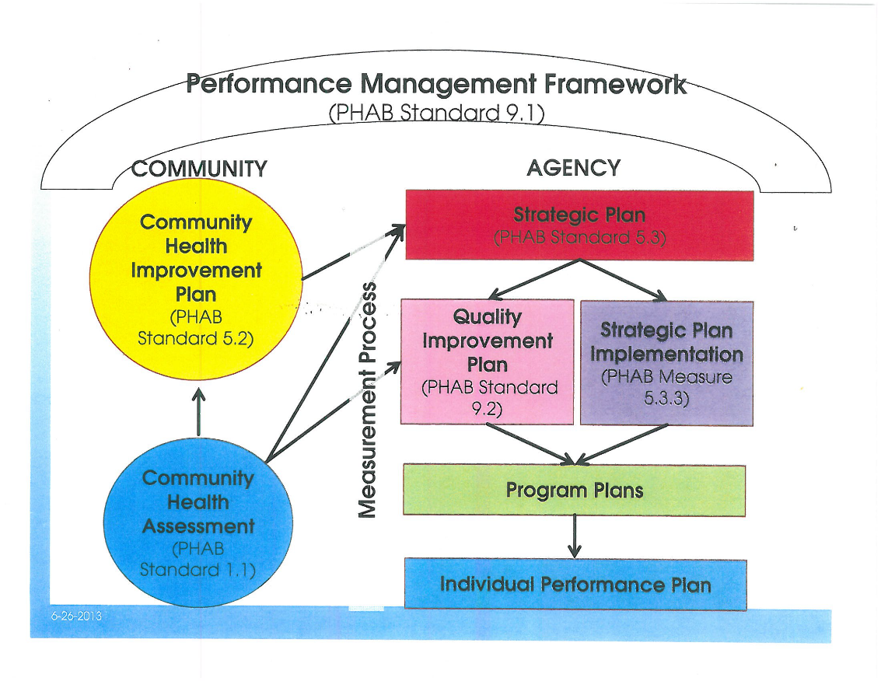
During the April 2019 assessment and revision of the current strategic plan, SCHD used this model to incorporate the concept of performance
of perf pe management within the current strategic plan.

In reviewing and updating the SCHD Strategic Plan, deliberate attention and discussion took place with the Accreditation Coordinator and Leadership Team regarding performance management as an important concept. Performance Management is the umbrella under which SCHD operates to make measurable positive change in population health. The strategic plan also introduces the conceptual model below, of performance pillars, or main themes under which the monitoring of strategic objectives will take place.
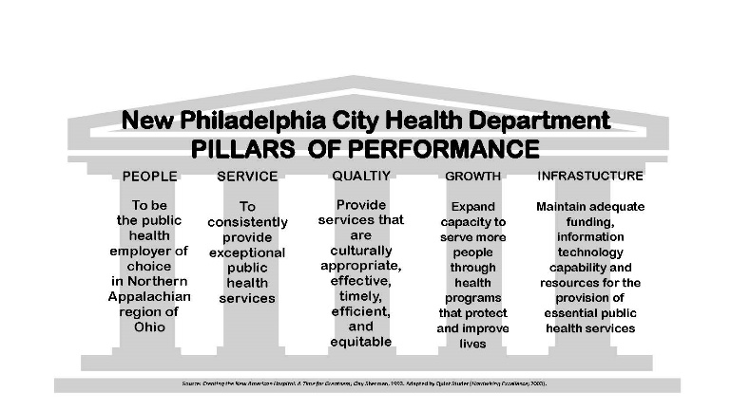

Staff committed to monitoring progress toward key performance indicators (KPIs) during monthly staff meetings to review progress and make adjustments or initiate further study to see if a quality improvement project was warranted. Quarterly, the staff review and update progress on the strategic plan. When designing the plan, division directors acknowledged that part of their performance review would incorporate progress toward achievement of strategic objectives.

DEVELOPING THE PERFORMANCE MANAGEMENT SYSTEM
Shortly after the SCHD Strategic Plan was revised in late 2019, monthly staff meetings began incorporating Performance Management, covering concepts such as:
- Performance management identifies actual results in comparison to planned or intended results
- Performance management systems aim to ensure that results meet the expected or intended outcome
- If intended results are not being met, they should be analyzed to identify opportunities and targets for improvement

ADOPTING A PERFORMANCE MANAGEMENT SYSTEM
In order to successfully integrate performance measurement and a culture of quality into the ongoing management of the organization, it was helpful to start with the Public Health Performance Management Framework, shown below, developed specifically for public health. This conceptual model describes the essential elements of a performance management system. The SCHD chose this model as their guiding principles for implementing a performance management framework. This framework was introduced and chosen during the spring of 2019 as part of the strategic implementation progress review.
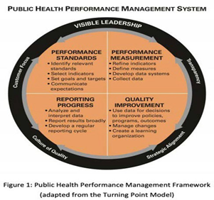
Following the May 2019 presentation, the Leadership Staff decided that they would take on the role of performance management the Performance Management Team. The Team developed a tracking system using white easel paper and decided to monitor the following objectives monthly:
After selecting the framework above, SCHD performed The Public Health Performance Management Self-Assessment Tool by the Public Health Foundation. Scores for the various sections were:
In August of 2019, as part of continuing education using the diagram below, the Leadership Team of NPCDH the Public Health Foundation’s, “Guide to the Stages of Performance Management,” to help the Leadership Team to understand that health departments make progress toward a culture of performance management by taking a journey of many steps, and that there are strategies for transitioning from one stage to the next. As part of the education session, Leadership discussed the model below and reached consensus that SCHD was in:
Stage 2: Awareness of Need for Performance Management and its Usefulness. The characteristics of this stage are that leadership wants to get out of the crisis mode of operation and begin making data-driven decisions; staff in leadership positions have attended local, tribal, state, or national conferences/trainings with a focus on performance management; performance management has become a topic on intermittent leadership agendas; measures are primarily focused on grant requirements; no centralized data collection system exists; and employees still fear how measurement will be used.
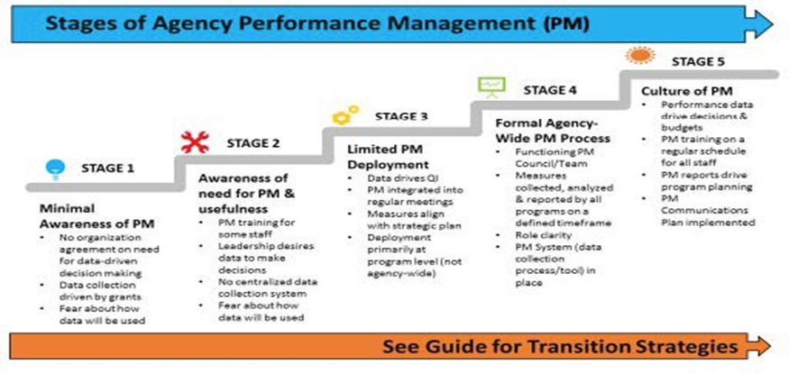
SCHD desires to transition to stage 5 which is defined as:
Stage 5: Culture of Performance Management: The characteristics of this stage are that performance data are used to make strategic decisions related to staffing, budgets, or new initiatives; staff present the process or outcomes of agency performance improvement efforts at local, state, tribal, regional, or national conferences; measures are visible throughout the agency; measure review and refinement occur regularly; performance management training occurs on a regular basis for all relevant staff positions; reports pulled for the performance management system are a daily tool for programs; and the performance management and QI processes are detailed policy/procedure/plan/.

Performance Management Plan

PART TWO: SCHD Performance Management Plan
Performance Management Purpose
It is the goal of SCHD to develop and maintain a performance management system that includes the four components of the model below.
In order to achieve this goal, SCHD will:
- Set specific performance management objectives for each of these core programs and include benchmarking (when possible) against similar agency, national, state, or scientific guidelines.
- Measure capacity, process, or outcomes of performance objectives.
- Report progress to local and district boards of health and other stakeholders on a regular basis.
- Incorporate performance management objectives with the agency’s current Quality Improvement Plan to continuously monitor and improve of the agency’s operations.
According to the Public Health Foundation, performance management practices have been shown to measurably improve public health outcomes, create efficiencies working with partners, and help public health workers solve complex problems. Other benefits of adopting a performance management system include better allocation of resources, prioritization of programs, changes of policies to meet current agency goals, and improve the overall quality of public health practice.

By adopting a Performance Management System, SCHD hopes to improve health, increase efficiency, and create other benefits for our community including:
- Better use of the dollars invested in public health.
- More accountability by funding agencies and the taxpayer’s dollar.
- Reduce duplication of services.
- Obtain a better understanding of the agency’s accomplishments.
- More of an emphasis on quality of services vs. quantity of services.
- Become more effective at problem solving.

Performance Management Plan
- Identification of Performance Management (PM) Coordinator
The Health Commissioner will appoint a PM Coordinator either from existing staff or through the agency recruitment process. The PM Coordinator will lead the agency’s efforts in its performance management plan.
- Identify Performance Standards for Core Programs
Staff assisted in the identification of the agency’s core programs and performance standards. The core programs are identified as:
  - Clinic Operations including immunizations, on and off-site vaccine clinics
  - Population-Focused Health (Wellness, Diabetes Education, Tobacco Education, CHA/CHIP)
  - Administration (Human Resources, Financial, Accreditation)
  - Environmental Services
- Development of Performance Management (PM) Team
The PM Coordinator along with the Health Commissioner identified existing staff members to serve on the agency’s performance management team. The Performance Management Team will meet quarterly each year during the following months: July, October, January, April.

The initial PM Team members are:

Name | Title
Michael Martin, MD | Health Commissioner
Melissa Spears, REHS | Accreditation Coordinator; Dept. Administrator
Tracey Henderson, RN, BSN | Director of Nursing
Garet Bennett, R.S. | Director of Environmental Health
Amber Gustin, | Fiscal Officer/Registrar

- Setting Performance Standards and Objectives for each Core Program
Each of the core programs identified in #2 above are required to identify at least two performance management objectives to measure for each health department fiscal year. The current performance measures are included as an appendix at the end of this document. All performance standards will use SMART objectives.
- Data Collection, Monitoring, Measure and Tracking
The collection of data for the performance standards will vary (Excel reports, e-reports, logs, etc.). Staff/ Department are responsible for the data collection, monitoring and reporting of the performance standards. Sub-committee members are required to continuously monitor and measure progress of the performance objectives for the core program(s) in which they are assigned. Tracking of performance standards will be done using Excel.

- Reporting and Sharing Performance Objectives
Progress on performance measures and objectives will be discussed and reported among staff at agency staff meetings, to the local board of health on an annual basis. Reports may also be shared with community members, partners, grant funders, other local public health agencies, state public health agencies, other local governmental agencies and the media. When reporting progress beyond the agency staff, the appropriate staff and managers will review performance data before it is reported out. This will allow for the most accurate, understandable performance reports. These reports may include charts, tables, and maps that are generally user- friendly and easy to understand.
- Identification of success/improvement strategies for Performance Objectives
The subcommittee determines if additional improvement strategies are needed to increase the success of reaching the objectives. Each subcommittee should incorporate the Plan-Do-Check- Act Cycle of the Quality Improvement Plan if additional improvement strategies are needed. When goals are not achieved, the subcommittee should demonstrate that critical thinking has taken place and quality improvement steps are taken to increase performance in that area in the future.
- Completing Agency Performance Management Self-Assessment
The agency PM Team completes a PM self-assessment every two years. The assessment tool used is the Performance Management Self-Assessment Tool by Turning Point Performance Management National Excellence Collaborative, 2004. A copy of the self-assessment template is included as an appendix to this document.
- Review and revision of the written plan will be done on an annual basis by the PM Team Members.
SCHD staff will be provided with access to any revisions made to the plan.
End of Performance Management Plan Section

Quality Improvement Plan 2019-2024

Quality Improvement Purpose
The Scioto County Health Department Quality Improvement (QI) Plan exists within the context of the mission, vision, values, and priorities of the Strategic Plan.
The strategic goals for SCHD are:
- Reduce morbidity and mortality due to disease, intentional and unintentional injuries, focusing on the reduction of incidence of opioid addiction and related poor societal outcomes
- Support staff by creating and implementing a workforce development plan and performance evaluation system
- Exceed state minimum standards for environmental service inspections
- Improve the quality of our services by creating and implementing a performance improvement plan and a quality improvement plan to guide SCHD in continuous improvement.
- Develop a branding and communication strategy that is culturally competent, timely and enables access to our services and engenders partnerships
- Ensure financial sustainability by obtaining one additional grant to support priorities in 2022.
A comprehensive performance management system involves strategic use of performance measures and standards to establish performance targets and goals, to prioritize and allocate resources, to inform managers about needed adjustments or changes in policy or program directions to meet goals, to frame reports on the success in meeting performance goals, and to improve the quality of public health practice. Development of a strategic plan was the first step in the SCHD’s performance management system. The QIC will use the strategic plan to identify and prioritize issues and opportunities for improvement, as well as other priorities as determined by the Health Commissioner. These may include quality measures that the Ohio Department of Health requires local health departments to report annually:
Additionally, The Ohio Department of Health requires Scioto County Health Department to annually report progress on the following key performance indicators:

#1) Decreasing Morbidity and Mortality due to disease
#2) Measure and Manage Environmental Health Conditions
#3) Increase Awareness and Adoption of Healthy Behaviors
#4) Measure and Manage Intentional and Unintentional Injuries
#5) Reducing Infant Mortality

Culture of Quality and Desired Future State
SCHD acknowledges the importance of quality improvement within an effective performance management system which includes a culture of quality, ongoing QI activities – both programmatic and administrative, and continued learning within the organization. Additionally, evolving environments in public health along with Public Health Accreditation Board standards and recommendations will be this plan’s focus to be an effective 21st century health department.
Continuing to strengthen SCHD quality culture includes the formation of a Quality Improvement Committee, creation of a written QI plan, implementation of QI activities, assessment of the effectiveness of the QI plan and its activities along with updating the QI plan on an as needed basis.
The future state of quality at SCHD includes the following:
- Continued growth of the QI & PM systems at SCHD, assuring participation in both systems by all employees of the department
- Demonstrated competence by all staff in a wide range of quality improvement tools
- Advanced agency QI maturity as evidenced by completed maturity assessments
- Data driven decision making to include program planning and prioritization.

Quality Improvement Structure
Quality Improvement provides ongoing operational leadership of continuous quality improvement and accreditation activities at SCHD.
The Health Commissioner has charged the QIC Team with carrying out the purpose and scope of the QI program in the department. The QIC is responsible for oversight of QI efforts and for promoting, training, challenging, and empowering staff to participate in the ongoing process of QI.
The QIC will develop the culture of quality by:
- Emphasizing QI as a way of doing work better, not as an isolated project
- Making building a culture of quality a long‐term objective
- Devoting suﬃcient resources to QI initiatives
- Providing incentives for embedding QI into daily work and seeking continuous improvement
The SCHD QIC will guide and evaluate the QI process by:
- Identifying, monitoring, and evaluating quality improvement projects
- Providing support to QI project teams
- Encouraging and fostering a supportive QI culture
- Implementing at least one QI project within the QI Team annually

QIC will make every effort to come to consensus on issues requiring a decision. However, if consensus cannot be reached, the QI Team will make decisions by a majority vote.
The QIC will meet at least quarterly as part of the monthly staff meetings. Minutes of the meetings will be maintained and shared with all staff. At least annually, the QI Team will provide a report of the QI program to the Boards of Health.

Alignment of QI Plan with Other Department Plans

LINKAGES TO OTHER PLANS
This QI plan links directly to the
- State of Ohio Health Improvement Plan (SHIP)
- The Community Health Assessment (CHA) and the Community Health Improvement Plan of Scioto County (CHIP)
- The Scioto County Health Department Strategic Plan (SP)
- The Scioto County Health Department Workforce Development Plan (WDP)

Linkage to the SHIP
STATE OF OHIO’S HEALTH PRIORITES - The Ohio Department of Health’s State Health Improvement Plan identifies the following priority health issues for the state which link to the SCHD strategic objectives which are monitored as part of our performance indicators are:
        - Mental health and addiction
        - Chronic disease
        - Maternal and infant health

Linkage to the CHIP
Specific to the Community Health Improvement Plan of Scioto County’s strategic priorities to:
- Decrease Adult and Youth Mental Health and Bullying
- Decrease Youth Substance Abuse
SCHD has strategic initiatives with SMART objectives that link to these CHIP areas in the SCHD 2019-2024 Strategic Plan,

CROSSWALK OF LINKAGES TO OTHER PLANS with SCHD Quality Measures

SHIP  Priorities | Ohio Dept Health KPIs | SCHD Strategic Priorities 2019-2024 | SCHD Strategic Plan Key Performance Indicators, that are tracked in the SCHD PM system.
Mental Health and Addiction | Decreasing Morbidity and Mortality due to disease | Reduce morbidity and mortality due to disease, intentional and unintentional injuries, focusing on the reduction of incidence of opioid addiction and related poor societal outcome. | Growing enrollment and increasing the success rate of clients in the Vivitrol Program with the following steps  - Implementing a quality improvement methodology to increase retention rate by 5% by 2024  - Influencing policy to advocate for treatment for all who need it.  - Working with Opioid Task Force and Quick Response Team to improve enrollment in treatment program from 3% to 7% by 2024.
Chronic Disease | Decrease Morbidity  and Mortality due to disease |  | Increase public/social media messaging to twice per month regarding mosquitoes and ticks during high risk season, 2019-2024.
Maternal and Infant Health | Reduce Infant  Mortality |  | Work with Bridges to Wellness pilot to open Vivitrol  program services to their clients in 2019-2020.
 | Measure and Manage Environmental Health Conditions | Exceed state minimum standards for environmental service inspections to protect public health | Increase number inspections by one more than state standard per inspection period, 2019-2024  - For pools  - For level III and IV food establishments  - Tattoo establishments  Publish information on the correct method to conduct soil borings to enhance protection of water supply and guard against contamination, 2023-2024.
 | Increase Awareness and Adoption of Healthy Behaviors | Increase the awareness and adoption of healthy behaviors through community partnerships,  educational programing and messaging, with culturally relevant materials created by engaging the community | Work with young adult population to increase education and outreach to reduce chlamydia infections by 5% in adults 25 years and younger by 2024.  Increase awareness of clinic increasing social media posts by 25%.  Increase leadership and participation in community  partnerships to reduce health inequities and decrease measures of health disparities in the new CHIP  in 2021-2024.  Begin engagement and outreach to Guatemalan population, 2019-2024.

Scioto County Health Department QI Goals and Objectives

The most important goal of the QI Plan is to nurture and grow the culture of quality at SCHD. SCHD will use the NACCHO Culture of Quality Self-Assessment Tool (2.0). This self-assessment tool is designed for managers, front-line, and other staff to assess the degree to which QI is integrated at the work unit or team level. The assessment is based on six foundational elements of a culture of quality, as defined by the National Association of County and City Health Official’s (NACCHO’s) Roadmap to a Culture of Quality, and those elements are further divided into 14-sub-elements. Respondents will score the agency on 27 diagnostic statements using a 6-point agreement scale.

Using survey results from a baseline assessment of the six foundational areas of staff empowerment, teamwork, leadership, customer focus, QI infrastructure, continuous quality improvement, staff will learn about and select strategies to implement over the life of this plan. Staff will take the survey annually to measure progress and develop strategies for future years.

Objective* | Timeframe | Person Responsible
100% of Leadership Team will have received Performance Management and QI training | 3/30/2024 | Accreditation Coordinator and Leadership Team
Staff will routinely report and discuss Performance Management and Quality Improvement at each monthly staff meeting | 03/01/2023 | Health Commissioner and all staff
100% of Staff will have received orientation to Performance Management | 3/30/2024 | Accreditation Coordinator and all staff
Complete a minimum of two QI projects, (1 admin & 1 program related: Swimming Pool and Fund Tracking | 6/30/2024 | QI Team Members
All job descriptions will be updated to include  expectation for involvement in QI training and team participation. | 7/1/2024 | Health Commissioner

*All objectives listed must be SMART (Specific, Measurable, Attainable, Realistic and
Timely.)

ORGANIZATIONAL STRUCTURE TO SUPPORT CONTINUOUS QUALITY IMPROVEMENT
Scioto County Health Department is committed to improving the quality of all its services, processes and programs and is seeking accreditation through the national Public Health Accreditation Board (PHAB). In order to accomplish both goals, a formal structure is necessary to lead and guide QI efforts within the agency.
The following describes the roles of SCHD’s leadership and staff to provide support for QI activities.
The Board of Health provides leadership, support, and resources for QI initiatives by
1. Establishing QI as an agency-wide priority
- Approving the QI Plan
- Recognizing improvements made through QI projects

The Quality Improvement Committee (QIC) The QIC is a function of the SCHD Leadership Team, consisting of the Health Commissioner, the Directors and the Accreditation Coordinator. The Health Commissioner reserves the right to assign or remove staff from the QIC in accordance with the needs of the Health Department.
The QIC provides on-going leadership in monitoring performance management and the initiation and oversight of QI activities. The QIC meets monthly, on the second Thursday of every month, as necessary, and will:
  - Develop, approve, evaluate and revise the QI Plan, including establishing goals, priorities and indicators of quality.
  - Review QI Plan annually to make necessary adjustments.
  - Make recommendations for QI projects.
  - Monitor QI Projects and provide Team Facilitators with advanced training in QI techniques for QI Team projects.
  - Set yearly QI goals and objectives
  - Under direction from the Leadership Team, the Accreditation Coordinator or the Health Commissioner, assess gaps in meeting PHAB standards and help facilitate a plan for improvement.
  - A designated member of the QIC will give monthly status updates during the
all staff meetings. These updates will consist of status updates on current QI projects, tracking of projects, any administrative support needed, and lessons learned for the implementation of various QI projects at the Health District.
  - Assist Directors with developing meaningful indicators and measures to monitor their operational performance and progress towards goals outlined in performance management plans.
  - Encourage, train and empower all employees to participate in QI processes.
  - Communicate to all staff the progress and success of various QI projects at all staff

meetings, through emails, or with storyboards placed in common areas within the Health District.
  - Seek additional resources for QI training for Health District staff or conduct trainings.
  - Participate in QI Trainings.
  - Review all Performance Management Plans (PMPs) annually.

Quality Improvement Team is a specific group convened to initiate a performance improvement project. This is triggered when a key performance indicator is not being met, or staff bring an opportunity for improvement forward during monthly staff meetings. The QI Team can name themselves for a specific project duration and assume the following responsibilities:
- Complete a QI Project Charter at the beginning of every QI Project.
- Report QI project progress and remain accountable to the QIC.
- Identify a Team Leader, Facilitator, and team members prior to beginning a project.

The Health Commissioner serves as the QI team project Champion and empowers the team to test and implement improvements in order to achieve targeted measures.
The Accreditation Coordinator can provide a project team with facilitation and documentation support, data analysis and expertise in using QI tools and LEAN processes during all phases of the project.
The Directors provide leadership, support and resources for QI teams as follows:
- Identifying and initiating problem solving processes that utilize QI tools and evidenced based practices.
- Overseeing QI projects in their area
- Participating in QI projects
- Scheduling staff time for QI projects
- Incorporating QI concepts into daily work
All Health District Staff are responsible for:
- Working with their supervisors and QIC members to identify areas for improvement and suggest QI projects to address these areas.
- Participating in QI projects as requested by Directors/Supervisors
- Collecting and reporting data for QI projects
- Developing an understanding of basic QI principles and tools by participating in QI training
- Incorporating QI concepts into daily work.

Reporting Out on QI Projects
In order to foster a culture of QI at SCHD, we recognize the importance of communicating the successes and effects of QI projects to the staff. To this end, each QI project will create a storyboard or graphic representation of the QI Team’s project to share with all staff at the monthly staff meeting. Upon request, the QI Team Leader will also present QI project results at Board of Health Meetings. Lessons learned from QI projects completed in the prior year will inform the QIC’s recommendations for revision to the agency’s QI Plan.

QI Training & Education

Training for New Employees
As part of the new employee orientation, all new hires will watch the one-hour webinar, “Building a Quality Improvement Culture,” produced by the CDC and available through the Public Health Foundation’s TRAIN National Website or at:

https://www.train.org/DesktopModules/eLearning/CourseDetails/CourseDetailsForm.aspx?courseId=1035229
New employees will also review a copy of the Strategic Priorities, the Performance Management and Quality Improvement Plan.
Training for Existing Staff
Ongoing training in QI tools and concepts are described in the SCHD Workforce Development Plan, including QI education and training focused on introductory concepts for all staff. See Appendix A for the 2020-2024 Training Schedule
As part of the QI Team, members are given the Public Health Foundation Public Health Quality Improvement Encyclopedia and are provided additional training on QI tools and methodologies. These include, but are not limited to: • Aim Statement • Affinity Diagrams • Brainstorming • Cause & Effect Diagrams • Data Collection & Analysis (Check Sheet, Bar Chart, Pie Chart, Run Chart) • Flowcharts • Gantt Chart • Storyboards • Quality Improvement webinars

QI Projects
The following section explains the process for QI project identification, selection, prioritization, implementation and tracking. Additional information about current or past QI projects can be obtained from the QIC Chairperson.

Project Identification & Prioritization
By monitoring our performance and listening to the voice of our customers/stakeholder and staff (feedback and suggestions for improvement) an opportunity for improvement via CQI project can be explored. Consideration will also be given to alignment of the proposed project with the Health District’s mission and vision, the capacity of the agency to take on the suggested QI project, the financial consequences (cost of staff time to complete project vs. potential financial benefit of QI project), and timeliness.
In addition, QI projects may be prioritized at the request of the Health Commissioner. To generate ideas for potential projects staff, or the QIC, may consider:

- Areas identified as needing improvement based on the Performance Management System
- After-action reports generated following outbreak investigations and emergency preparedness events and exercises
- Client or employee satisfaction surveys
- Staff suggestions
- Findings, audit or compliance issues
- Incident reports
- Performance appraisals

Implementation of a project
Any staff member can initiate a QI project request. Potential QI projects can be brought to the QIC section of the monthly staff meeting, or as warranted to the Leadership Team by any employee, the management, leadership team or intern. Requests can be triggered by review of key performance indicators, strategic plan goals and objectives, or other processes or programs that need improvement to reach targeted outcomes or be more efficient.
QI Projects are carried out following the Plan-Do-Check-Act cycle (PDCA) described below.
PLAN
To present a QI project for consideration, fill out the Project Submission Form in Appendix B. Individuals are encouraged to meet with the supervisor in the affected work area before completing the form. Necessary steps prior to filling out form may include:

- Identifying a problem or opportunity for improvement. Typical areas include time, cost or quality of work produced.
- Defining the process that needs to be improved.
- Defining the scope of the process: from the first step of the process to the last step.
- Identifying metrics that can be used to measure current state and success of quality improvement project.

A completed Project Submission Form can be presented at the next monthly staff meeting under the QIC section of the agenda, or the Health Commissioner can convene a QIC special meeting to initiate the project sooner. Once the QIC approves the project, the Health Commissioner assigns team roles, and the team leader sets a team meeting schedule. A Project Charter Form, Appendix C, is completed at the first meeting.

Typical activities that the team completes in the Plan phase are:

- Affirm the scope of the project and redefine as needed.
- Make a flow diagram of the process
- Collect and analyze baseline data
- Utilize QI tools such as the 5 Whys, a Fishbone Diagram, a Failure Mode Effect Analysis, in order to understand the root cause of a process problem in order to formulate a hypothesis.
DO
Once the team develops the hypothesis, they report the hypothesis at the next staff meeting and discuss the change to implement in the process, in order to see if the intervention or change in the process will make a positive improvement. Unless re-directed by the Health Commissioner, the team moves on to the Do phase and implements the test or pilots a new process.

CHECK
In the check phase, the post-test data is collected to see if an improvement was made. If not, the team may perform further analysis and re-perform the Plan or Do phase with a new hypothesis. If an improvement was made, the team moves on to the Act Phase.

ACT
The project moves out of the pilot phase and the change or process intervention is enacted in order reach improvement goals. In this phase a story board is completed by the team and presented at the next staff meeting. Process data is monitored for two years to ensure that the process is in control and that quality targets are being met.

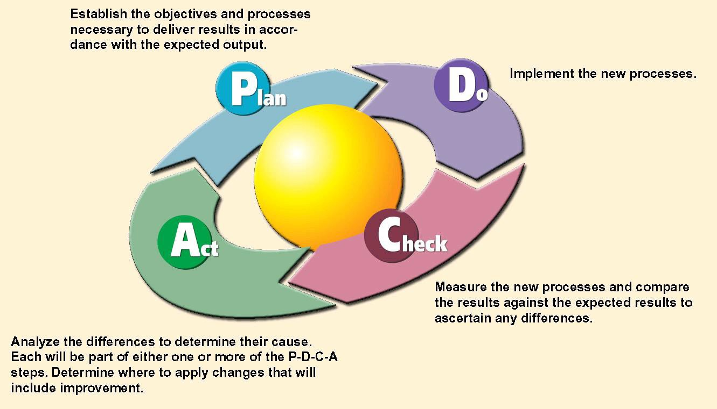
PDCA Cycle Used for QI Projects

Assessing Effectiveness: QI Plan Management and Maintenance
This QI Plan will be evaluated by the members of the QIC in February of every year. Modifications and adjustments to the plan can be made by Leadership Team as needed throughout the year. Annually, the SCHD staff will evaluate the following aspects of the QI Plan:
- Whether Plan goals and objectives were met
- The effectiveness of the QIC
- The clarity of the QI Plan and associated forms and appendices
- The effectiveness of the QI Plan for overseeing projects
- Integration with the SCHD mission, vision, Workforce Development and Strategic Plans.

Quality Improvement Project Monitoring

Data Collection and Monitoring

Data will be collected for each performance measure and each QI project. It will be the responsibility of each lead staff member as identified in the performance management plan, for collecting and monitoring data for their own measure. It will be the responsibility of each project team leader to collect and monitor data for their own QI project. Assistance and support will be provided by the Health Commissioner and/or Accreditation Coordinator as requested.
Progress reports on QI will be given by the team leader at each monthly staff meeting for each project, indicating which phase of the project is being performed and any barriers or learnings will be reviewed. of project data. This information may be presented in the form of a storyboard.
  - All data reporting will be included in the project documentation and QI project outcomes will be highlighted in the SCHD Annual Report.
  - To assure project outcome sustainability, data will be monitored at intervals decided by the process owner for two-years post project completion.

Actions to Make Improvements Based on Progress Reports

Based on progress reports, the Leadership Team and/or the QI Team may make recommendations or suggestions regarding implementation of QI projects and/or determine if a performance measure issue is significant enough to warrant the implementation of a QI project.

Sustaining QI Project Outcomes

QI project outcomes data will be monitored for at least two years after the QI project has closed. This data will be reviewed bi-annually at QI Team meetings. Unfavorable outcomes will be addressed with program/process investigation and additional QI as needed.

Communication of QI

Several methods will be used to assure regular and consistent communication. These methods include, but are not limited to the following:

Key Message | Mode of Communication | Target Audience
Opportunities to apply QI tools  and methods | QI Team Meetings and when applicable, All Staff/Program Meetings | Staff
QI outcomes, lessons learned,  resources | QI Team Meetings, All Staff/Program Meetings, Board of Health Meetings | Staff, Board of Health
QI training opportunities | QI Team Meetings, QI Project Team Meetings, All Staff Development training | Staff
QI branding, definitions, and  value | Storyboards, visuals | Staff
Progress on QI Team goals and  objectives | Storyboards, visuals, QI Team  meetings | Staff
QI 101 | Online Training Modules | Staff
Annual QI Project Summary, contained in Annual Report | QI Team Meetings, All Staff  Meetings, Board of Health Meetings | Staff, Board of Health

References

National Association of County and City Health Officials (NACCHO). Quality Improvement in Public Health. (2015). Retrieved April 8, 2015, from http://www.naccho.org/topics/infrastructure/accreditation/quality.cfm

National Committee on Quality Assurance. (n.d.). Retrieved on April 8, 2015, from http://www.ncqa.org/HomePage.aspx

Public Health Accreditation Board. About Us. (2013). Retrieved April 8, 2015 from http://www.phaboard.org/

Public Health Accreditation Board. Acronyms and Glossary of Terms, Version 1.0 (2011). Retrieved April 8, 2015, from http://www.phaboard.org/wp-content/uploads/PHAB-Acronyms- and-Glossary-of-Terms-Version-1.0.pdf

Public Health Foundation. About Performance Management. (2011). Retrieved April 8, 2015, from, http://www.phf.org/resourcestools/Documents/About_Performance_Management.pdf

Appendices
Appendix A: QI Training Schedule 2020-2024
Appendix B: Project Submission Form
Appendix C: Project Charter Form
Appendix D: Quality Improvement Reporting Form Appendix E: Storyboard Template
Appendix F: Sample Storyboard from Delaware General Health District Appendix G: QI Projects

Appendix A
QI Training Schedule 2019-2022

Program | Source | Required Personnel | Date to Complete
Performance Management  Planning | Center for Public Health  Practice; OhioTrain - ID1103140 – Clear Impact | Accreditation Coordinator | April 2023
Overview of PM | Center for Public Health Practice; | Leadership Team | August 2023
Webinar 1 on PM | OhioTrain – ID 1103037 | Leadership Team | August 2023
Webinar 2 on PM | OhioTrain – ID1103135 | Leadership Team | August 2023
Webinar 3 on PM | OhioTrain – ID1103138 | Leadership Team | August 2023
Webinar 4 on PM | OhioTrain – ID1103139 | Leadership Team | August 2023
Webinar 1 on CQI | OhioTrain - ID1074896 | Leadership Team | August 2023
Webinar on CQI 101 | OhioTrain – ID 1067632 | All staff | November 2023
Webinar – PM & the Oversight of Roles of Boards of Health | OhioTrain – ID1092846 | Board of Health | November 2023
Self-Paced Course – OSU – CQI for Public Health: The Fundamentals | The Ohio State University-Center for Public Health Practice – Online Learning | Leadership Team  All Staff | March 2024
Self-Paced Course – OSU-Writing a QI Plan for Your Agency | The Ohio State University-Center for Public Health Practice – Online Learning | Leadership Team | March 2024

Public Health Foundation
Performance Management (phf.org)

OhioTrain
www.train.org

Create an account

The Ohio State University – Center for Public Health Practice – Online Learning
https://u.osu.edu/cphp/free-online-learning/

Appendix B

Quality Improvement Project Submission Form
To initiate a quality improvement idea or project, complete this submission form, and present at monthly staff meeting.

Employee Name: |  |  |  |  |  |  |  |  |  | Date:
Program:
Idea/Project:
What would you like to improve?
Do you have information/evidence/data available to support the need to work on this topic?
 |  |  |  |  |  |  |  |  |  |  | Yes | No
If yes, please describe here:
What kind of improvement will result? (Select all that apply):
 | Enhanced Employee Performance
 | Improved Teamwork and Communications
 | Improved Use of Resources
 | Improved Working Conditions and Employee Morale
 | Increased Efficiency
 | Improved Quality of Services
 | Increased Safety
 | Reduced Cost
 | Reduced Waste
 | Satisfied Customers/Stakeholders
 | Other:
What is the desired result? (Example: Reduced Turn Around Time)
Who will benefit? (Check all that apply) |  |  |  | Program |  | Public |  | Staff |  |  | Other:

Which of the six areas of public health responsibility does this QI project align with? (Check all that apply)
Assure an adequate local public health infrastructure
Promote healthy communities and healthy behavior
Prevent the spread of infectious disease
Protect against environmental health hazards
Prepare for and respond to disasters and assist communities in recovery
Assure the quality and accessibility of health services

QI Proposal Approval | Approved / Date | Declined / Date
Scioto County Health Department
Team Champion/Health Commissioner

Scioto County Health Department QI Project Charter

Project Title

Project Facilitator Agency/Organization Charter Last Updated Date:

Project Description/Statement of Work (What problem will we address?)
Problem Background/ Business Case (why is the project important now?)
Customers and customer needs/requirements
SCOPE (DEFINE BOUNDARIES) | First step in the process:
 | Last step in the process:
Project Goals
Project Constraints
Performance Metrics: What measures will tell you if you are successful. |  |  | Performance Metrics
 |  |  | Current | Goal | Final | % Change
Projected Benefits
Project Team
Team Lead:
Team Champion/Sponsor: Process Owner:
Team Members:
Subject Matter Experts:
Project Champion/Sponsor and Process Owner Sign-Off: I am committed to supporting this project and
implementing the team’s improvements.
Sponsor Signature: Process Owner:
36
Scioto County Health Department Quality Improvement Plan

Appendix D
PLAN
 | Agency: |  |  | Scioto County Health Department
 | Project Title:
 | Aim:
 | Impact:
 | Measures: (Include both process and outcome measures.) |  |  | Outcome Measure:  Process Measures:
 | Team Member:
 | Month/Year: |  |  |  | Reported By:
Please summarize the key action steps you have taken in the past month. |  |  |  |  |  | Describe the results of your action steps and what you learned from the process.
D O | 1. |  |  |  |  |  |  | CHECK
 | 2.
 | 3.
 | 4.
ACT |  | 1.  2.  3.  4.
What are you most proud of achieving?
What were the costs incurred for conducting this QI project?
Salaries and Fringe |  |  | $
Travel |  |  | $
Equipment |  |  | $
Supplies |  |  | $
Printing |  |  | $
Other: |  |  | $
TOTAL |  |  | $

Quality Improvement Reporting Form

pg. 212727
37

Scioto County Health Department Quality Improvement Plan

POPULATION SERVED:
TITLE:

Appendix E: Story Board Template

PLAN
Identify an opportunity and Plan for Improvement |  | of the Test

1. Getting Started
Start typing here
7. Check the Results
Start typing here

5. Develop an Improvement Theory
ACT
Standardize the Improvement and Establish Future Plans
Start typing here

2. Assemble the Team
Start typing here

8. Standardize the Improvement or Develop New Theory
Start typing here

DO
Test the Theory for Improvement

- Examine the Current Approach
Start typing here

- Identify Potential Solutions
Start typing here
6. Test the Theory
38
Start typing here
9. Establish Future Plans
39
Start typing here

pg. 222727
CHECK
Use Data to Study Results

40
Scioto County Health Department Quality Improvement Plan

Appendix G: Quality Improvement Projects

Project Title | People | Dates | Objective
Let it Flow | Melissa Spears, Garret, Leah, Kelly Friar | Initiate Project March 2019 | Reduce number of broken flow meters found during pool inspections.

41

